Ansible:

**Ansible** is simple open source IT engine which automates application deployment, intra service orchestration, cloud provisioning and many other IT tools.

Ansible is easy to deploy because it does not use any agents or custom security infrastructure.

**1)ad hoc commands**

Ad hoc commands are commands which can be run individually to perform quick functions. These commands need not be performed later.

For example, you have to reboot all your company servers. For this, you will run the Adhoc commands from ‘**/usr/bin/ansible**’.

These ad-hoc commands are not used for configuration management and deployment, because these commands are of one time usage.

ansible-playbook is used for configuration management and deployment.

**2)playbooks**

Playbooks are the files where Ansible code is written. Playbooks are written in YAML format. YAML stands for Yet Another Markup Language. **Playbooks** are one of the core features of Ansible and tell Ansible what to execute. They are like a to-do list for Ansible that contains a list of tasks.

Playbooks contain the steps which the user wants to execute on a particular machine. Playbooks are run sequentially. Playbooks are the building blocks for all the use cases of Ansible.

**3)roles**

Roles provide a framework for fully independent, or interdependent collections of variables, tasks, files, templates, and modules.

In Ansible, the role is the primary mechanism for breaking a playbook into multiple files. This simplifies writing **complex playbooks**, and it makes them easier to reuse. The breaking of playbook allows you to logically break the playbook into reusable components.

**Steps:**

1)launch two ec2 instance(master and slave)

And put that keys in one folder and open gitbash there

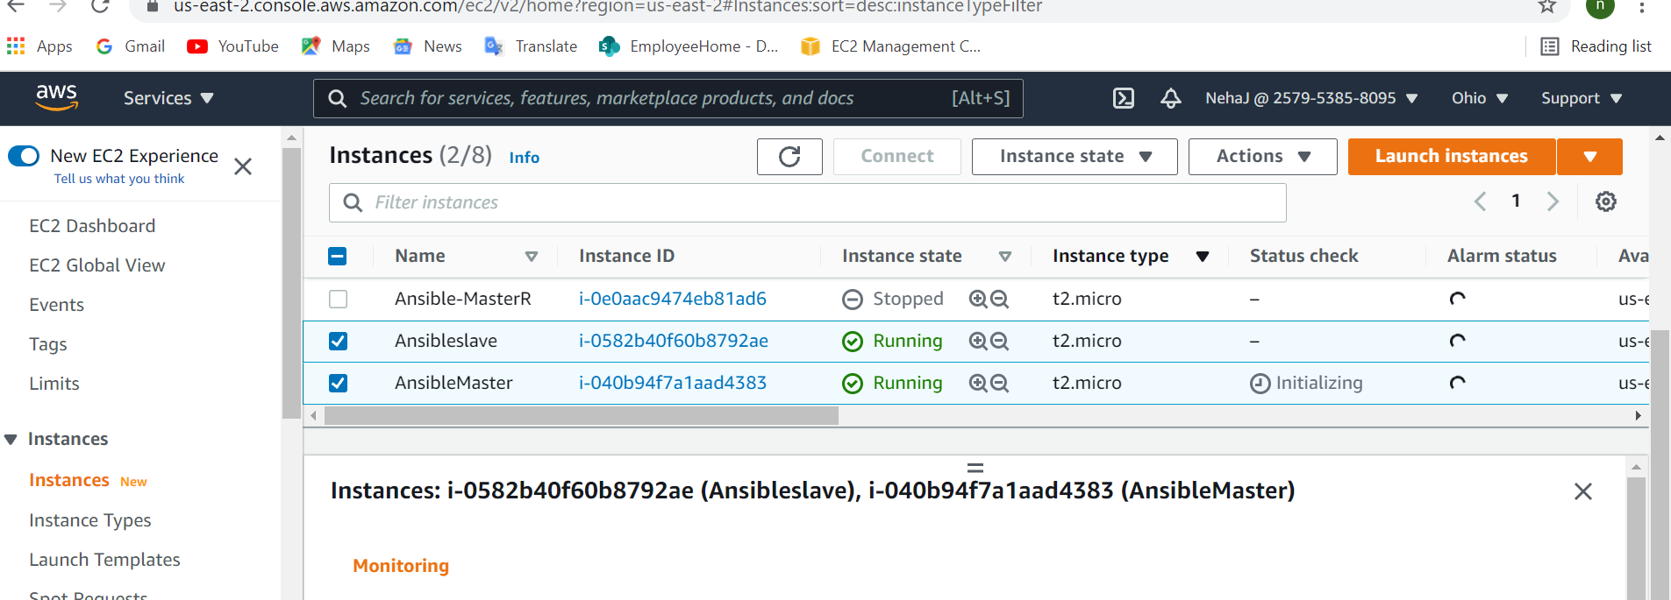

2)run command ssh -i ansiblemaster.pem [ubuntu@3.144.174.185](mailto:ubuntu@3.144.174.185) and logged into master

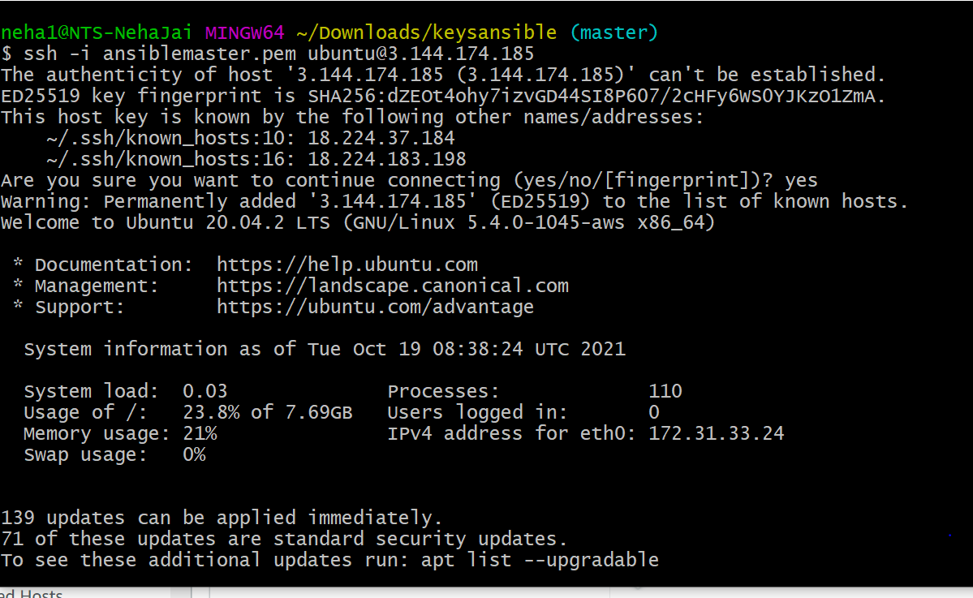

3)go to root folder by sudo su

And then run ssh-keygen

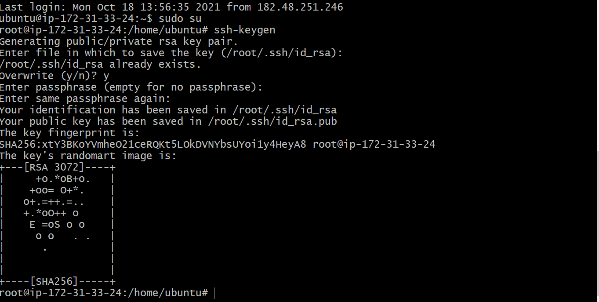

4)same logged into slave mode

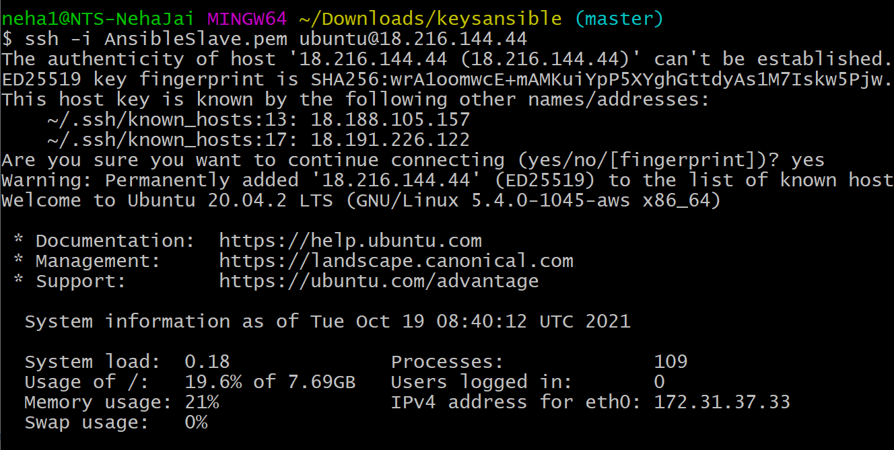

5)run command Vim /etc/ssh/sshd_config



6)change the permission

Remove # of permitrootlogin

And put # on password authentication

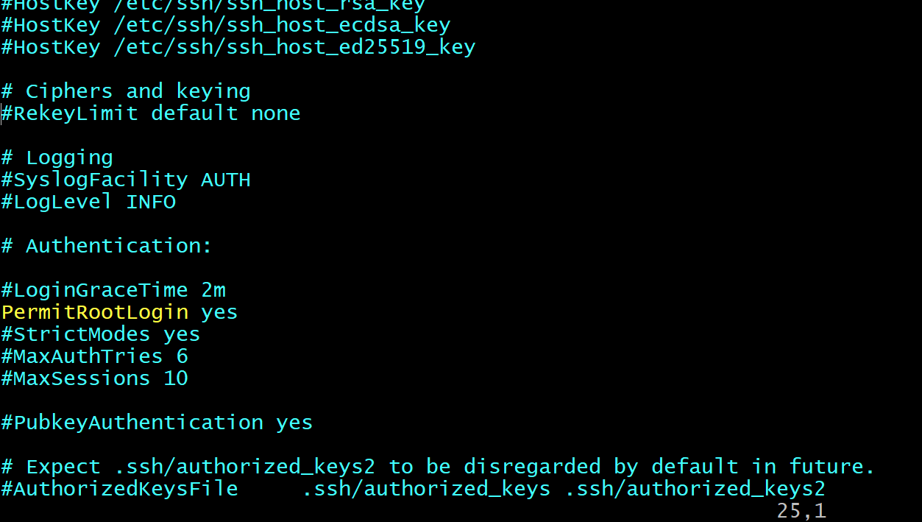

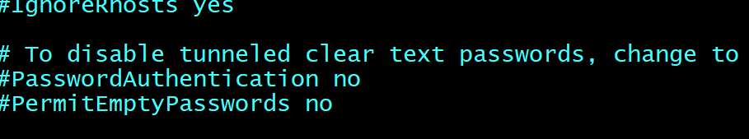

7)restart sshd by systemctl restart sshd



8)set the password using sudo passwd root

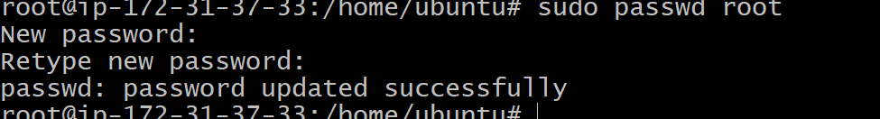

9)run command to copy id from slave in master

ssh-copy-id root@172.31.37.33

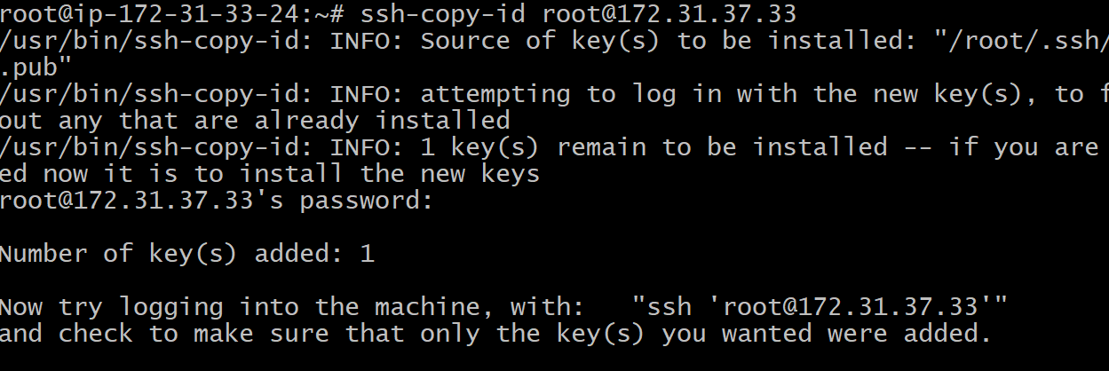

10)now In master node type:

Vim /etc/ansible/hosts inside that type

[webserver]

172.31.37.33

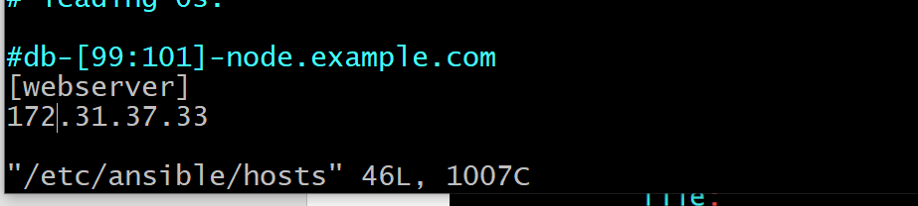

11)run ansible-m ping webserver



12)in master

1)make directory

mkdir ansible

2)go to dir cd/ansible

3)create file vim demo.yml

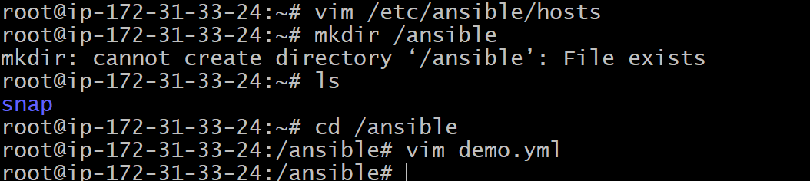

13)inside demo.yml wite below script

Save file esc :wq

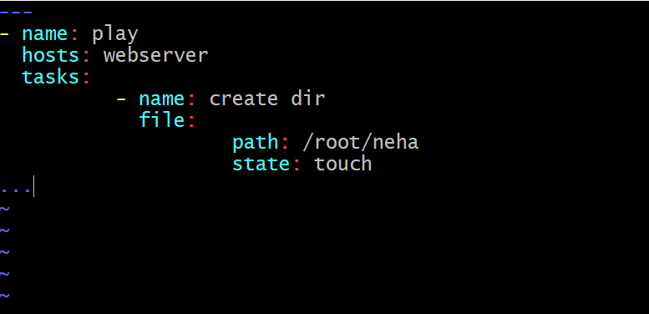

14) check status ans dyntax of playbook by

* ansible-playbook demo.yml –syntax-check

Then

* Ansible-playbook demo.yml

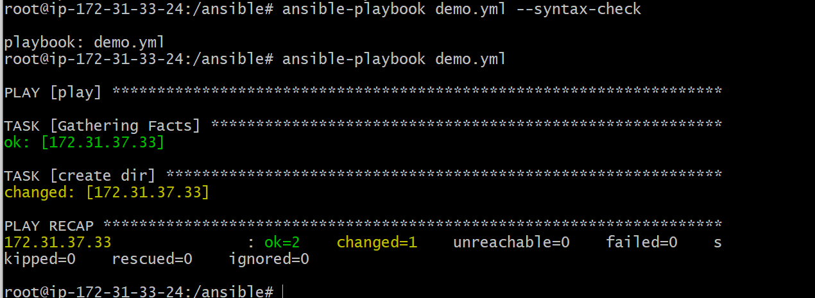

15) now in slave mode check file using ls /root



* Roles:

1)Initialize role using ansible-galaxy role init apache2

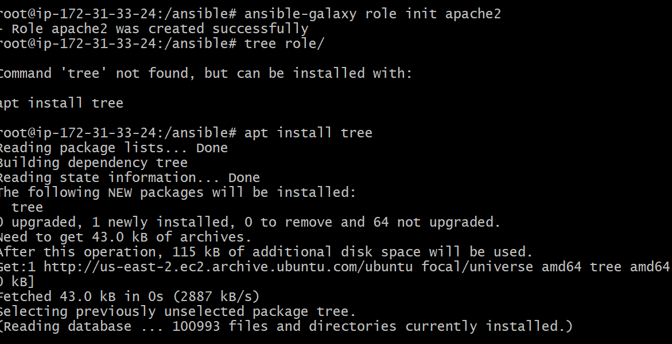

2)create new file role.yml and go to vim role.yml and write the script

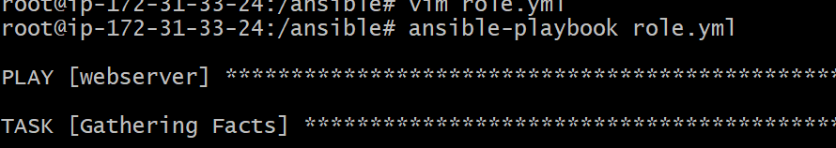

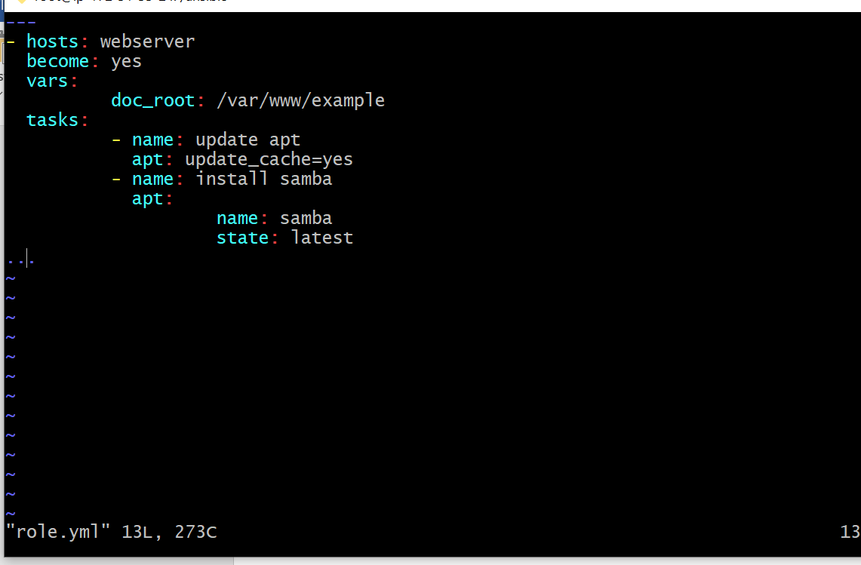

3)save by esc :wq

4)run the file using ansible-playbook role.yml

